Name ___________________
ACTIVITY 6-5 SH
IS IT CONSISTENT?

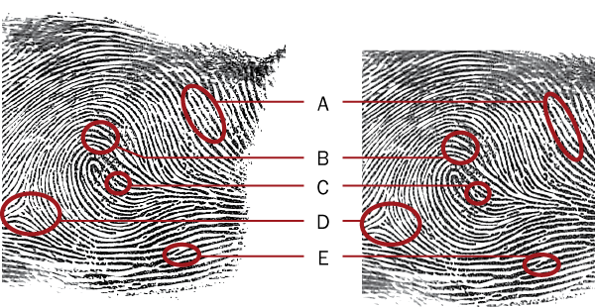

All photos © Cengage Learning

- Identify each of the patterns labeled in the ridge pattern diagram. Refer to the chart on minutiae in the text.

A. _____________________________________________

B. _____________________________________________

C. _____________________________________________

D. _____________________________________________

E. _____________________________________________

- Examine each of the fingerprints below. Using a red pen and referring to Figure 6-9 in your text, circle the minutiae pattern and then label it with the appropriate number.

Arthur
All photos © Cengage Learning

1. Bifurcation

2. Island ridge

3. Ridge ending

Doris

4. Eye

5. Spur or hook

6. Ridge ending

Alice

7. Double bifurcation

8. Island ridge

Suspect
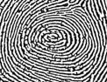
Suspect
What patterns can you find in this print?
_____________________________________________

_____________________________________________

_____________________________________________

